„A Strange, Strange Duck and her even stranger adventures”

written by: Julia Kruszyńska, Bartosz Lemański, Kamil Zaremba, Krystian Cichoń, Oliwer Błażak and Grażyna Ślęzak
Zespół Szkół Specjalnych w Żninie, Poland
illustrated by: Kamil Zaremba, Julia Kruszyńska, Krystian Cichoń, Bartosz Lemański, Oliwier Błażak
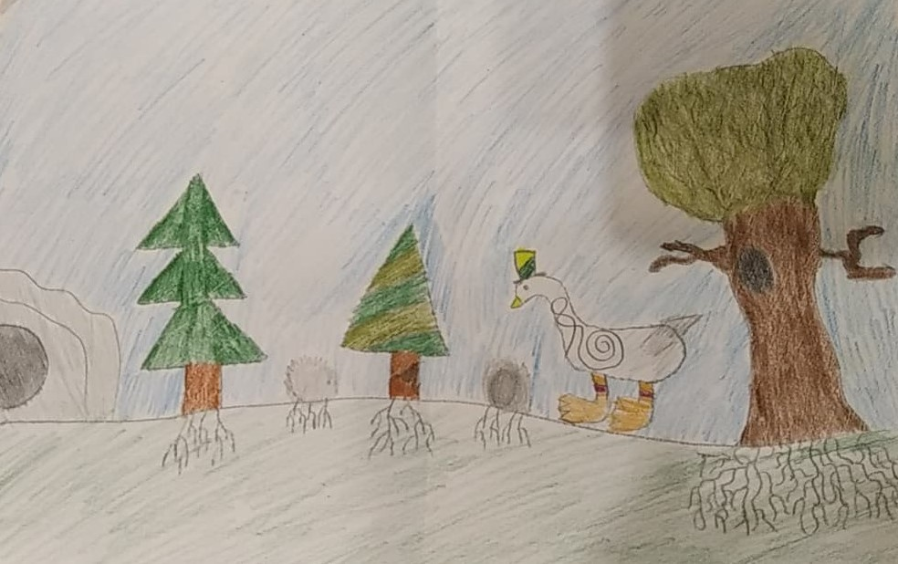

Once upon a time, in a small town in Poland, which lied by the beautiful river Noteć, lived a Strange, Strange Duck. At first glance, she seemed to be a plain and completely ordinary duck. White feathers, a yellow beak and legs. Really, nothing special. However, there was more to it than met the eyes. There were a few out of the ordinary information about her. One of them was the fact, that she very much enjoyed wearing sports shoes. Secondly, the Strange, Strange Duck simply loved travelling throughout Poland in those sports shoes!
One day, the Duck planned a winter trip to a famous ski jump in Wisła, a city where many famous Polish ski jumpers practised. After a long journey, she reached the place. To her amazement, she saw Adam Małysz, a legendary ski jumper, sitting very worried nearby. As it turned out during the conversation, he was sad because of the global warming there wasn’t any snow on a ski jump. As a result, he and his fellow ski jumpers were unable to train. The Duck was surprised by the news. She had never heard about the global warming but it seemed unimportant to her. She waved her wings to say „Goodbye” and flew back completely unconcerned to Noteć.
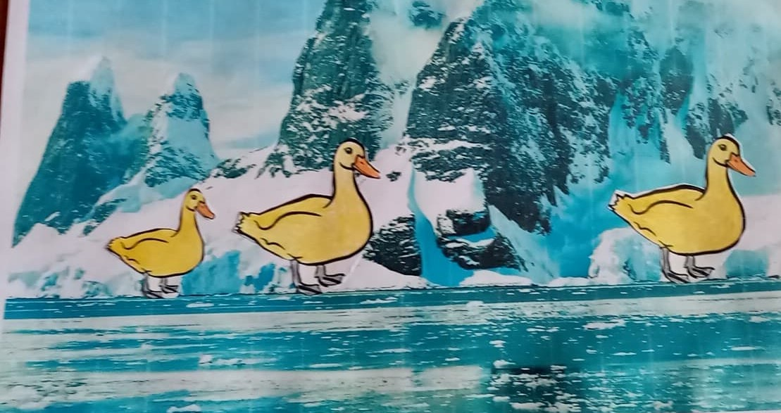
On returning home, the Duck rested for a short while and soon started planning another journey. This time she went for a sightseeing trip to Mazury, which is a well known region of Poland with many beautiful lakes and beaches. Simply a paradise to those, who love sailing a boat, fishing and relaxing in a quiet surrounding. It was spring time so the Duck hoped for a pleasant stay. After her arrival, she met an old friend of hers, Mateusz Kuśnierewicz, a world-famous sailor. He offered a sailing tour to the Duck. It was a hot and sweltering spring day. They started off. Unfortunately, an hour later the weather suddenly changed. Dark clouds covered the sky, the wind became very strong. A thunderstorm started, with dramatic lightning and heavy rain. Thanks to enormous experience of Mateusz, they managed to return to the shore safely. The sailor said, that such freak weather conditions have become more frequent recently and were unusual for this season of the year.
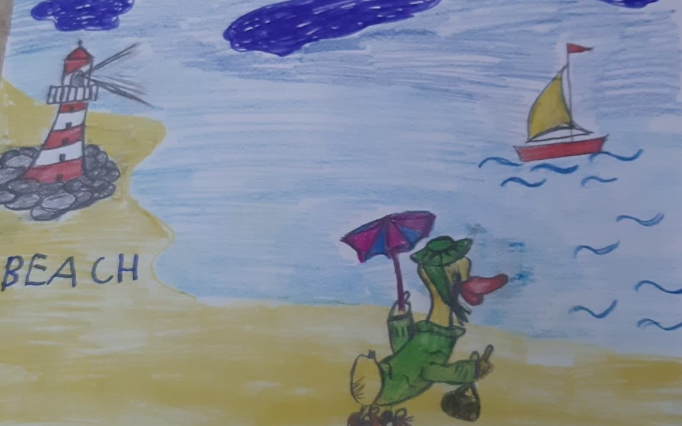

On the way back home, the Duck decided to stop by in Bory Tucholskie, a wonderful large pinewood forest in central Poland. The sight terrified her. Lots of rubbish, such as plastic bottles, candy wrappers, empty cans were scaterred over a wide area. The duck started crying, feeling helpless and angry at the same time. „Why people are so reckless about the environment that surrounds all of us?”, she asked but there was no-one to answer…
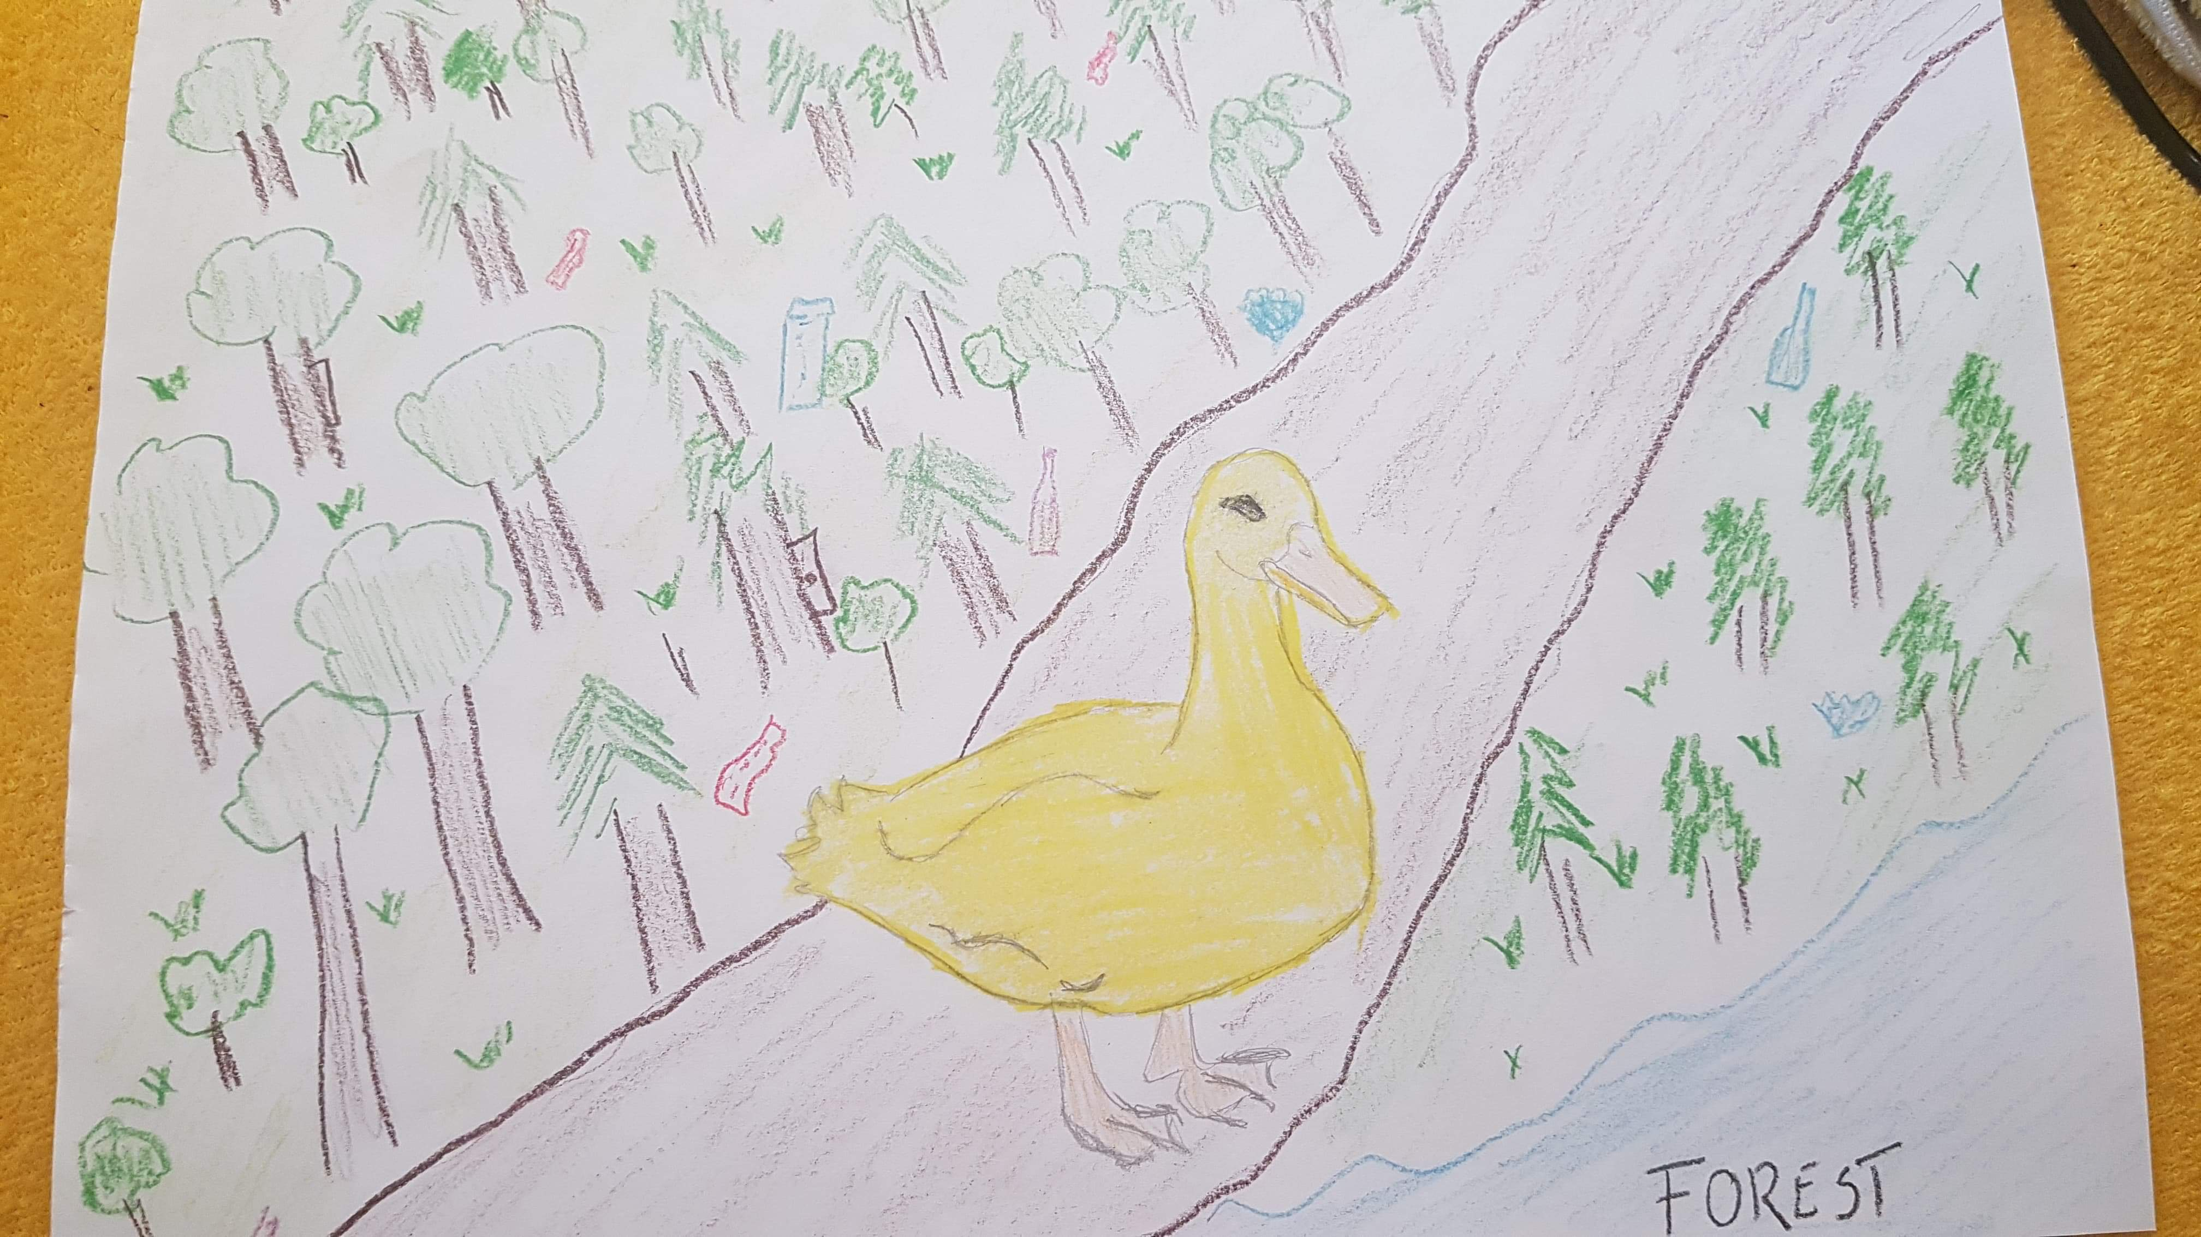

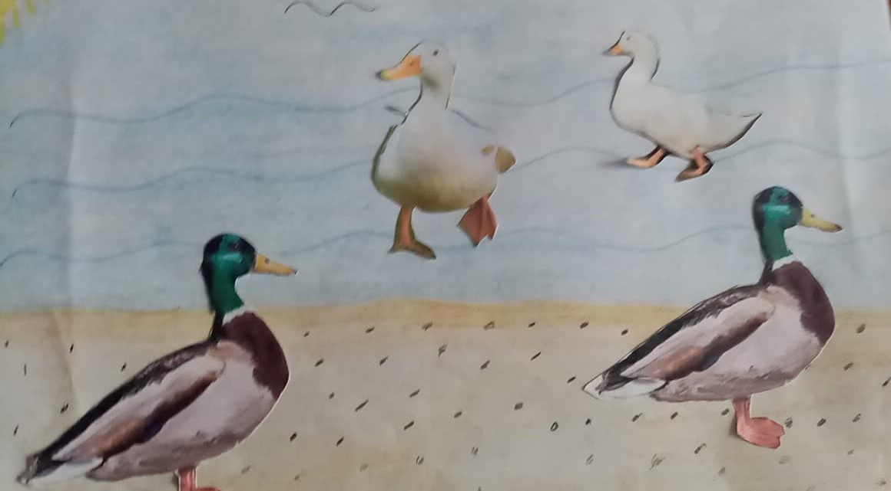
The Strange, Strange Duck returned home again. She felt more and more puzzled. Recent adventures left her anxious and uneasy. Some time passed and a beautiful Polish summer started. Our adventurer decided to go to the Baltic Sea and visit her favourite fishing village. She was craving for relax, beach sand, a lot of sun and sea water. Shortly after her arrival, the Duck went down to the beach. To her utter amazement, the scenery the Duck saw was dreadful. The beach almost disappeared bacause the water level rose so much! This was too much for a little animal like her. She sat down on the beach, lost in thought. The more she pondered, the more miserable she got. Finally, she came to the conclusion that all those atmospheric changes were connected and appeared to be a result of a climate change on a bigger scale. But how big was it?

To find out, the Duck decided to go on a much longer journey, to visit her friends penguins in freezing Antarctica. Once she got to Antarctica, she noticed that something was wrong there too. The Duck expected the weather to be cold and icy. Instead, it was warm and sunny! Penguins were scared. They told her, that the glaciers had been melting for some time rapidly. There wasn’t enough space to lay eggs and nurture their offspring. The Antarctic animals placed all their hope in the Strange, Strange Duck. Her mission was to return to the mainland and persuade people to stop producing harmful greenhouse gases.
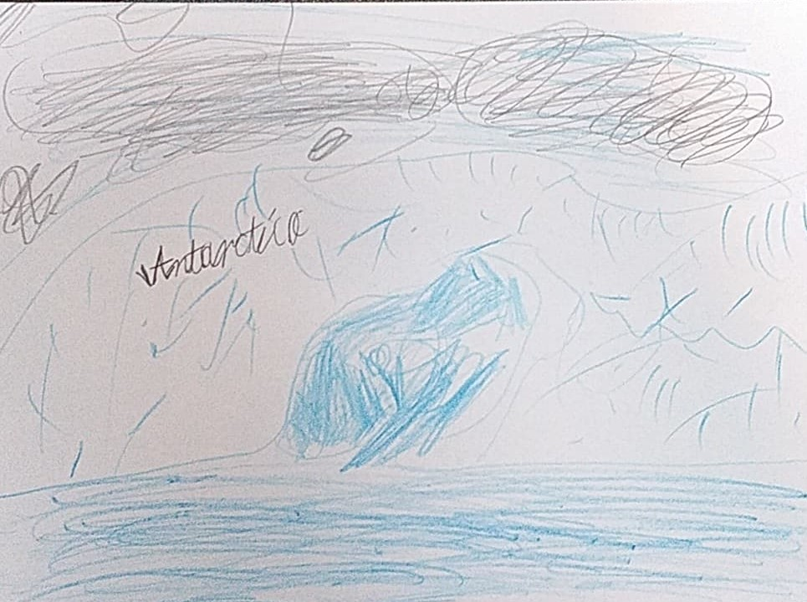

This time the return home was different. There was no resting or relaxing. The Strange, Strange Duck decided to save all beautiful places in Poland and in the world. She browsed through many books on global warming in the local library, consulted well-known professors about the climate change and was ready to ACT! Moreover, as she talked to people and other anilams, the Duck discovered that the awareness of the problem was insufficient. Thankfully, many of her friends decided to help her. Together they organised an enviornmental festival near the Noteć river and promoted ecological slogans about segregation of rubbish, energy and water saving and alernative means of transport. Moreover, she managed to involve school pupils in planting trees on the outskirts of her town.
The Duck was aware, that she was unable to stop the global warming on her own. She knew, that her actions were only a drop in the sea of needs. On the other hand, there were billions of people all over the world. If each of us does one little thing to stop the climate change, it will rise to a great extent on a global scale. We all have to start feeling responsible for our everyday actions and choices concerning the environment. We can’t just sit back and watch the destruction of the climate!!! The Duck was ready to make her contribution. ARE YOU READY TOO?
THE END

